**PREDICTING THE PRICE OF BITCOIN**

# PREPARED BY

June Njuraita

Felista Mueni

Faith Nanzala

Sylvia Nganga

Sammy Murimi

Joseph Leshakwet

# **TABLE OF CONTENTS**

**TITLE PAGE**

**TABLE OF CONTENTS** 1

I**NTRODUCTION** 3

**PROBLEM STATEMENT** 4

**METRIC OF SUCCESS** 4

**RESEARCH DESIGN** 4

**BUSINESS UNDERSTANDING** 5

Main Objective 5

Specific Objectives 5

Research Questions 5

Data Mining Goals 6

**DATA UNDERSTANDING** 6

Data Exploration 6

Data Quality 7

**DATA PREPARATION** 7

Data Cleaning **7**

**EXPLORATORY DATA ANALYSIS** 9

Univariate Analysis 9

Bivariate Analysis 11

Multivariate Analysis 11

**FEATURE SCALING** 12

**MODELING** 12

# 

# 

# 

# **INTRODUCTION**

Bitcoin is a form of digital currency whose aim is to do away with the need for central authorities such as banks.Bitcoin makes use of blockchain technology that supports peer-to-peer transactions between its users through a decentralized network.

Bitcoin transactions are authenticated through the proof-of-work consensus mechanism, which gives rewards to cryptocurrency miners for validating their transactions.

Bitcoin was launched in 2009 by an anonymous developer known as Satoshi Nakamoto. It was the first, and has remained as the most valuable asset among cryptocurrencies.

Bitcoin is a digital asset that can either be stored in a digital wallet or at a cryptocurrency exchange. Each individual coin represents the value of Bitcoin’s current price in relation to either the US dollar or other world currencies. It's possible to own partial shares of each coin. The smallest unit of each Bitcoin is called a Satoshi. Each Satoshi is equivalent to a hundred millionth of one Bitcoin, so owning fractional shares of Bitcoin is quite common.

Bitcoin is powered by open-source code known as blockchain, which creates a shared public history of transactions organized into "blocks" that are "chained" together to prevent tampering. The technology creates a permanent record of each transaction, and it provides a way for every Bitcoin user to operate with the same understanding of who owns what.

A Bitcoin wallet contains both a public key and a private key, which work together to allow the owner to initiate and digitally sign transactions. This unlocks the central function of Bitcoin — securely transferring ownership from one user to another. Users on the Bitcoin network verify transactions through a process called mining, which confirms that new transactions are consistent with other transactions completed in the past. This ensures that you can’t spend a Bitcoin you don’t have, or that you have previously spent.

# **PROBLEM STATEMENT**

Despite its popularity, the Bitcoin market is relatively new and has been subject to high volatility. There is a need to understand the factors that drive the price of Bitcoin, and to make predictions about future price movements. The information from our analysis will help potential investors to make sound decisions in regards to buying and selling of bitcoin.

# **METRIC OF SUCCESS**

This research will be considered a success when we are able to predict the price of bitcoin for the next one year by looking at:

1. Market capitalization: This report will track Bitcoin’s market capitalization over time to determine its overall value in the market.
2. Trading volume: The report will analyze Bitcoin’s Trading volume to determine the level of demand for the currency and its liquidity in the market.
3. Price trends: The report will track Bitcoin’s price over time and identify any significant trends or patterns.

# **RESEARCH DESIGN**

In this research,we use the Cross Industry Standard Process for Data Mining as our research design to comprehensively dissect the problem of financial inclusion in East Africa and help in the contribution of the solution, will constitute the following steps:

* Business Understanding
* Data Understanding
* Data Preparation
* Analysis
* Evaluation

# **BUSINESS UNDERSTANDING**

Over the recent years,there has been immense growth in the use of bitcoin all over the world.In some countries like Central African Republic and Ecuador,bitcoin has become a legal tender.In most parts of the world it is used as a medium of exchange, a form of investment for both storing wealth and speculation.Therefore establishing the trends in price will equip investors with information with regard to the ROR,when to put up stop losses and come up with strategies to cushion them against extreme losses.

## **Main Objective.**

Our main objective is to predict the price of bitcoin.

## **Specific Objectives**

1. Identify the trends of bitcoin.
2. Identify the features that have an impact on bitcoin.
3. Identify the highest volume recorded by Bitcoin (USD).
4. Identify the lowest volume recorded by Bitcoin (USD).

## **Research Questions**

We will aim to answer the following questions;

1. What is influencing Bitcoin trends ?
2. What features have an impact on the price of Bitcoin?
3. What is the highest volume recorded by Bitcoin in a day, (USD)?
4. What is the lowest volume recorded by Bitcoin in a day, (USD)?

## **Data Mining Goals**

In effort to sync our business objectives and data science, we establish the following goals that will help deliver the above research using data science techniques:

* Web Scraping : This was done using beautiful soup
* Exploratory data analysis : univariate, bivariate and multivariate analysis on the data variables.
* Feature Scaling
* Modeling
* Challenging our model
* Conclusions and recommendations
* Deployment

# **DATA UNDERSTANDING**

This data was scraped using beautiful soup from the CoinMarketCap website which is a price tracking website for crypto assets and it contains bitcoins data from April, 2013 to February, 2023.The data can be accessed through this [link](https://coinmarketcap.com/currencies/bitcoin/historical-data/)

The data frame created contains 3585 rows and 7 columns.

The specific features include ;

* Open: the opening price, the price at which an asset, in this case, Bitcoin, trades at the beginning of the day. (USD).
* High: the maximum price of the day, the highest price reached by Bitcoin on that day, (USD).
* Low: the minimum price of the day, the lowest price reached by the Bitcoin on that day, (USD).
* Close: the closing price, the price at which Bitcoin trades at the end of the day, (USD).
* Volume: the sum of actual trades made during the day, (USD).
* Market cap: Market capitalization, the total value of all shares of a company or, in the case of Bitcoin or another cryptocurrency, of all coins in circulation, (USD).
* Timestamp: date of the record.

## **Data Exploration**

Exploration is important in any research as it helps identify errors,checking for any unique values which helps in the preparation of the data for data cleaning.

In this research, we used python to display the different features in the dataset including the column information,the shape of the dataset,the head and tail of the dataset.

## **Data Quality**

After previewing and exploring the data,data cleaning processes are required to make sure that the data being used is of quality and one that will give the most accurate results possible.

# **DATA PREPARATION**

This is the process of making sure the data achieves and maintains quality for the final use in the research.

For this research, this was done through data cleaning.

## **Data Cleaning**

In data cleaning,we go ahead to check for the uniformity of the data which was done by ensuring that all data types are in a format that can be used in the research.We convert the timestamp column to date time format.We went ahead and converted the market cap and volume columns to float and in 2 decimal points.

We also established that there are no missing values.

We plotted boxplots for all the variables.The output of the boxplots show that there are outliers. We went ahead and checked how many records of outliers we have and decided to continue with the dataset as in this case the outliers are an indication that there is variation in the prices over a short period of time.

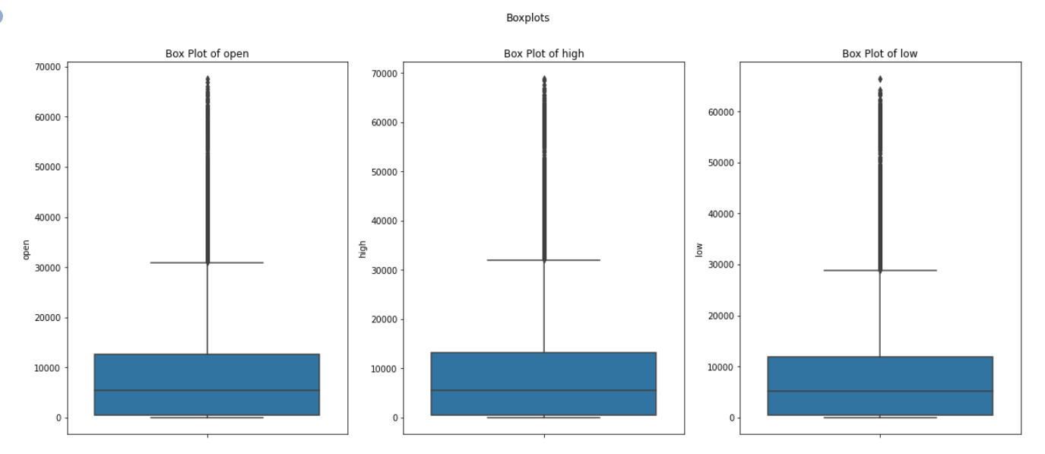

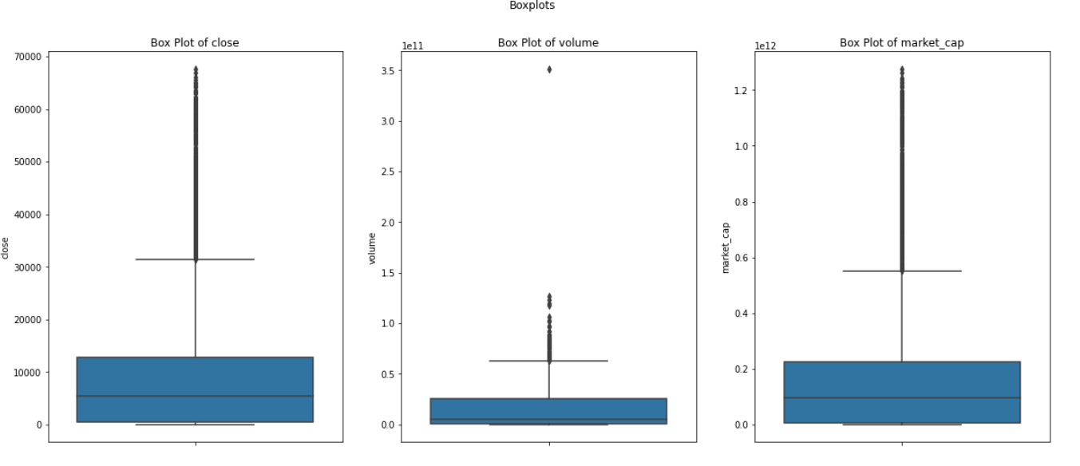

# 

# **EXPLORATORY DATA ANALYSIS**

Exploratory data analysis that was conducted include:univariate analysis,bivariate analysis and multivariate analysis.

## **Univariate Analysis**

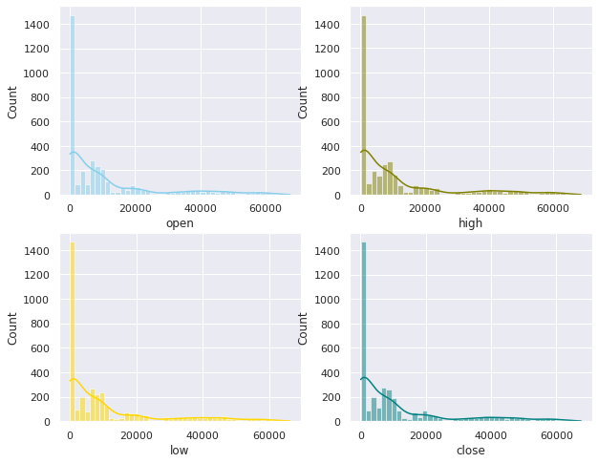

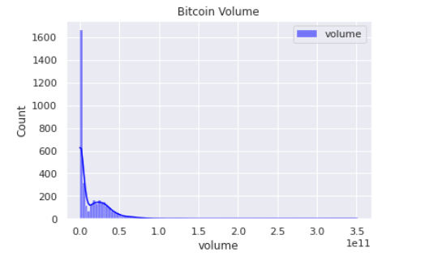

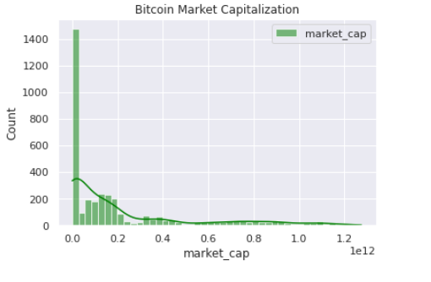

Observation

* From all the above histograms,it was depicted that there is positive skewness.

## **Bivariate Analysis**

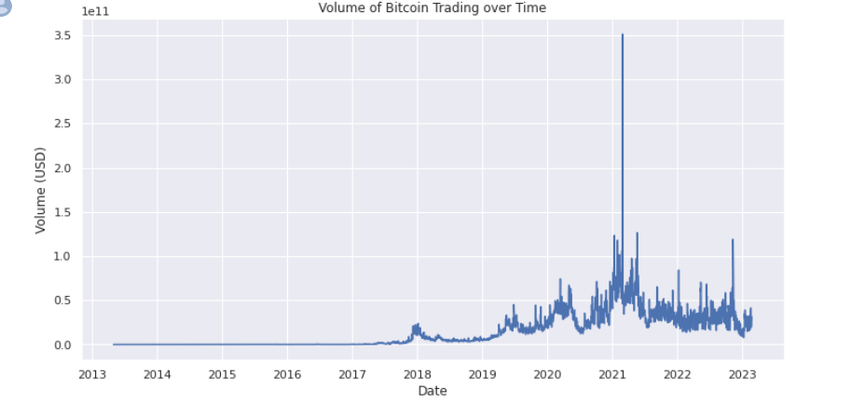

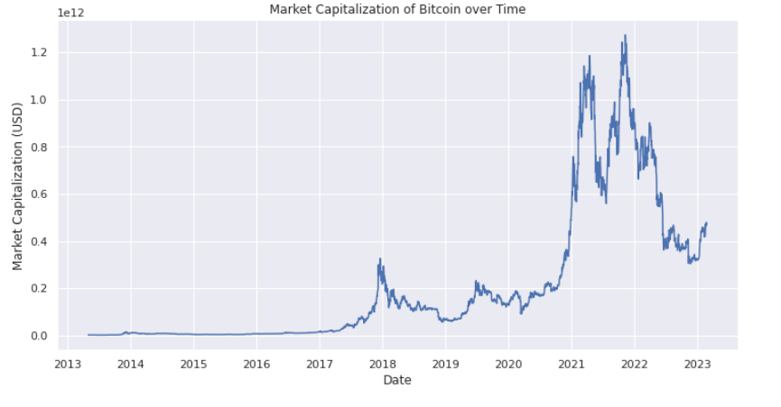

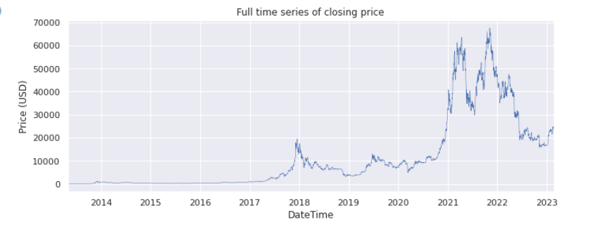

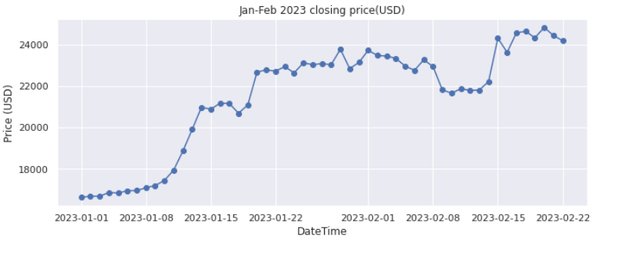

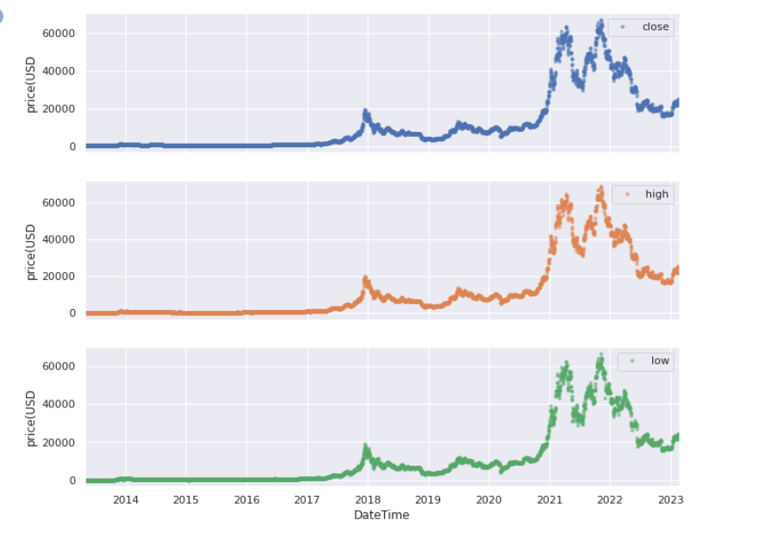

Observations

* The volume of bitcoin traded has been rising and the highest level reached in the first quarter of 2021 being over 35,000,000,000 USD.
* The market capitalization has been rising where the maximum value was realized in 2021 first quarter at around 1,250,000,000,000 (one trillion two hundred and fifty billion eight hundred thirty-one million) There have been instances when the rise has eased off and declined like in the end of 2018 and on 2020 before rising again and making more highs.
* The full time series graph shows a slow rise in the price of bitcoin from 2013 to around mid 2017 where it starts rising with the highest prices recorded in mid 2021 and end of 2022 where it starts dropping.
* From the daily closing price for the year 2023,we can see that there is a steady increase in closing price as from 1st january 2023 to around 13th January and 14th and 15th there was a slight decrease
* As from 20th January the closing price continued also to increase upto around 26th.A slight decrease was noted at around 27th and 28th of January
* There is noted also a big drop in closing price as from 8th Feb to 14th february
* The high ,low and close bitcoin prices have similar trends where they rise and fall in a similar manner.

## **Multivariate Analysis**

The following observations were made from the analysis :

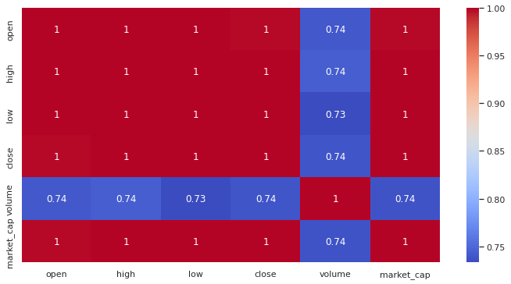

Observation

* There is a perfect positive correlation among all the features except for volume which has a strong correlation with the other features

# **FEATURE SCALING**

This was done using min max scaler to normalize all the columns as a measure to ensure the model performance is optimized.

# **MODELING**

After normalizing the data,we went ahead to split the data into train and test.We identified the close column as our target variable while all other columns after dropping the close column were our features.The data was split to 80% train data while 20% test data.

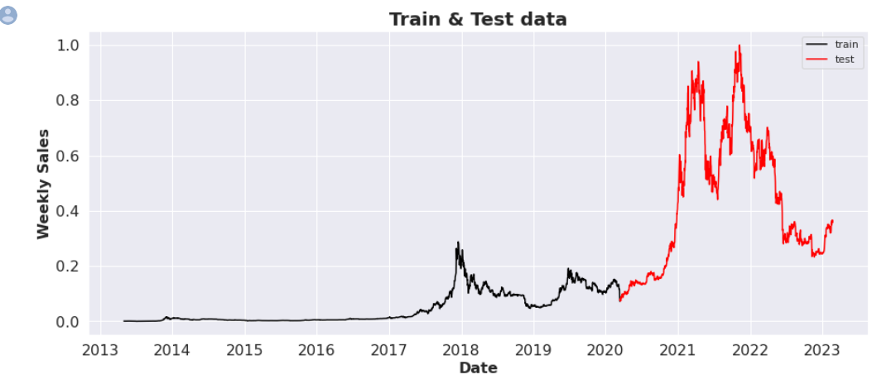

The above is a line graph to show what data was used for training and that which was used for test.The data from 2013 to early 2020 was used as our train data while from early 2020 to February 2023 was used as test data.

We used XG Boost to create our first model where we fit the x and y train into the XGBRegressor , made predictions factoring in mean absolute error and the root mean squared error.Then went ahead to compare the original close price vs the predicted close price.

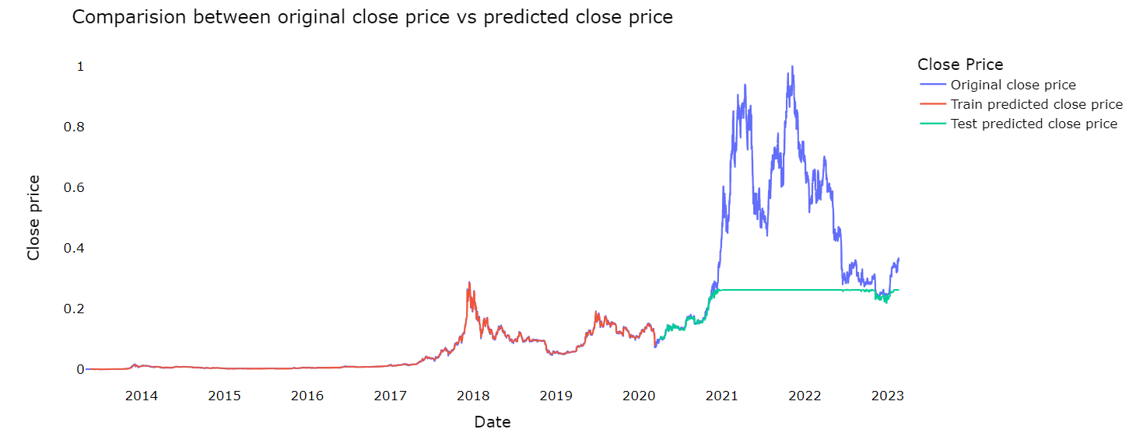

We went ahead to combine the original data and the predicted data.

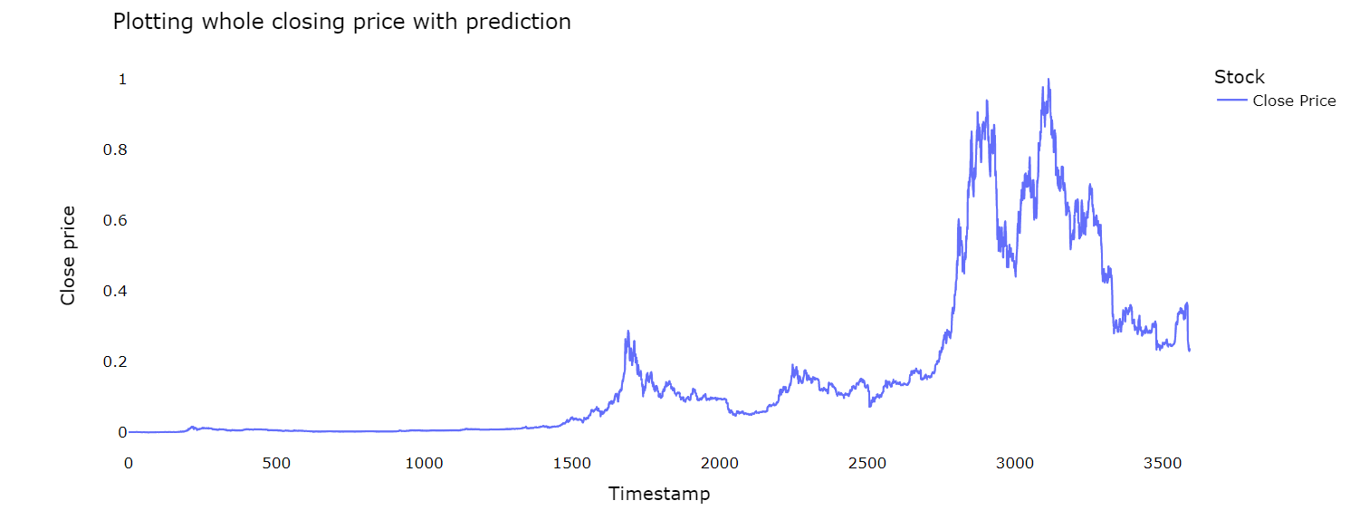

## **Challenging the model using LSTM**

We imported relevant libraries,loaded our dataset,split train test our dataset to 70%,30%.Scaled our data using min max scaler and assigned training values.

We went ahead to create a model using the relu activation function,factoring in mean squared error and the adam optimizer.

Went ahead to fit the training data to the model created.We assigned the test and predicted values,reshaped and inverse transformed using the scaler.

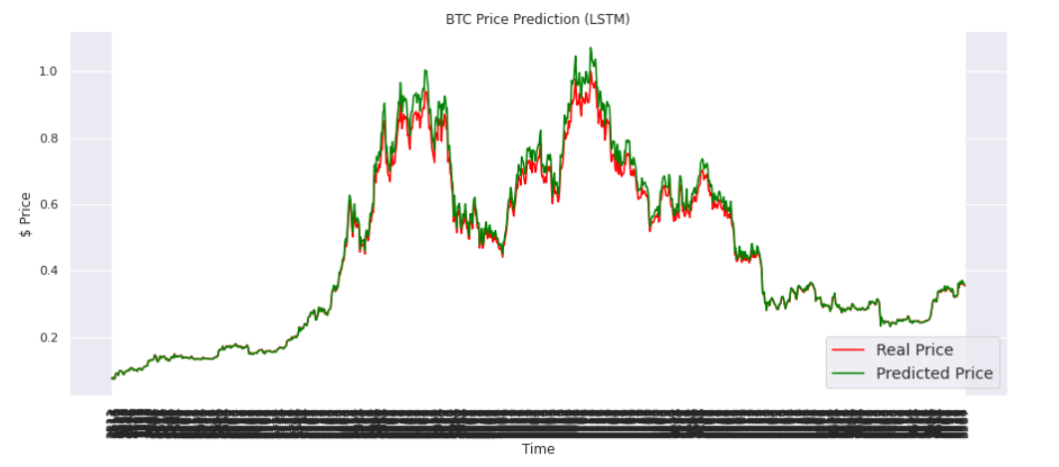

# **MODEL DEPLOYMENT**

# **CONCLUSIONS**

In conclusion,

1. Bitcoin has generally been increasing in price, it sometimes falls but it then recovers and continues rising
2. The opening price the high price and the volume together with market capitalization affects the price of bitcoin
3. Bitcoin has recorded a volume of zero and has gone to as high as 35,000,000,000

# **RECOMMENDATIONS**

1. For the investors who want to invest in bitcoin, they can invest as the price will rise in the long term.
2. Bitcoin is a good cryptocurrency to invest in as the volume traded and the market capitalization have risen very much making it good to invest in.